HazardRatio: A SAS macro to generate confidence intervals for the hazard ratio in randomized clinical trials
By Gang Cheng
February 8, 2016
HazardRatio is a SAS macro to generate Wald, Peto’s, and score confidence intervals (CIs) for the log hazard ratio in randomized clinical trials. The point estimate, standard error, and p-value for each method is also generated. The Wald CI is based on the maximum partial likelihood estimator (MPLE) and the corresponding Fisher information matrix. Peto’s CI is based on the log-rank statistic and its variance estimator (Peto et al., 1977). The score CI is constructed by inverting the partial-likelihood score test under the Cox proportional hazards model (Lin et al., 2016).
This macro is defined with the name “HazardRatio” as:
%macro HazardRatio (Data = Data, Time = Time, Status =Status, Stratum =, Treatment = Treatment, Alpha = 0.05, Accuracy = 0.001, Result = HR_CI);
……..
%mend HazardRatio;
The following parameters are provided:
- Data: specifies the dataset to be used. The default name is “Data”.
- Time: specifies the event time. The default name is “Time”.
- Status: indicates, by the values 1 versus 0, whether the event time is observed or censored. The default name is “Status”.
- Stratum: specifies a numeric variable that defines the strata. For unstratified analysis, leave the argument for this variable blank.
- Treatment: specifies a binary variable, e.g., 0 for placebo and 1 for test drug. The default name is “Treatment”.
- Alpha: specifies the confidence level (1-Alpha). The default value for Alpha is 0.05.
- Accuracy: specifies the accuracy of the score confidence limits. The default value is 0.001.
- Result: specifies the file storing the results, including the point estimates, standard errors, CIs, test statistics, and p-values for the Wald, score, and Peto’s methods. The default name is “HR_CI”.

Examples:
The file “colon” contains the data from a clinical trial on adjuvant therapy for patients with resected colon cancer. A snapshot of the data is provided below. The variable “Treatment” indicates, by the values 1 versus 0, whether the patient received the combined therapy of levamisole and fluorouracil or observation. The variable “Stratum” is based on the number of lymph nodes. The variable “Time” is the time point at which the patient is either censored (Status = 0) or observed to die (Status = 1).
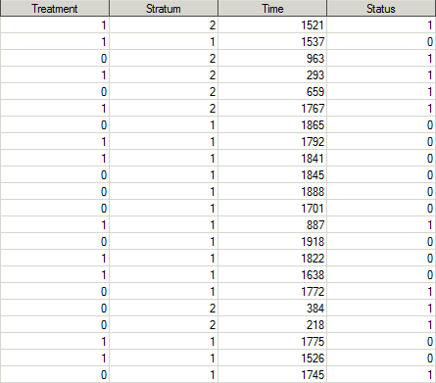
Unstratified analysis (Stratum not specified)
The following SAS statement is implemented:
%HazardRatio (Data = colon, Time = Time, Status = Status, Stratum =, Treatment = Treatment, Alpha = 0.05, Accuracy = 0.000001);
The results are stored in the file with the default name of “HR_CI” as follows:
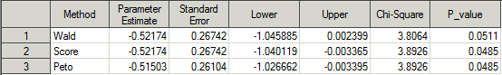
The results for the three methods are provided in three rows. The columns “Parameter Estimate” and “Standard Error” provide the point estimate and standard error for the log hazard ratio. The MPLE is used as the estimate of the log hazard ratio for the score method. The columns “Lower” and “Upper” show the lower and upper limits of the confidence interval. The test statistic and p-value are stored in the columns “Chi-Square” and “P_value”.

Stratified analysis (Stratum specified):
The following SAS statement is implemented:
%HazardRatio(Data = colon, Time = Time, Status = Status, Stratum = Stratum, Treatment = Treatment, Alpha = 0.05, Accuracy = 0.000001);
The results are stored in the file with the default name of “HR_CI” as follows:
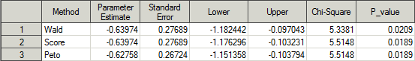
References:
Peto, R., Pike, M. C., Armitage, P., Breslow, N. E., Cox, D. R., Howard, S. V., Mantel, N.,
McPherson, K., Peto, J., and Smith, P. G. (1977). Design and analysis of randomized
clinical trials requiring prolonged observation of each patient. II. analysis and examples.
British Journal of Cancer 35, 1-39.
Lin, D. Y., Dai, L., Cheng, G., and Sailer, M. O. (2016). On confidence intervals for the hazard ratio in randomized clinical trials. Biometrics.

